#1 Wanted: kids’ camp teachers

Why is this GEP teacher smiling?
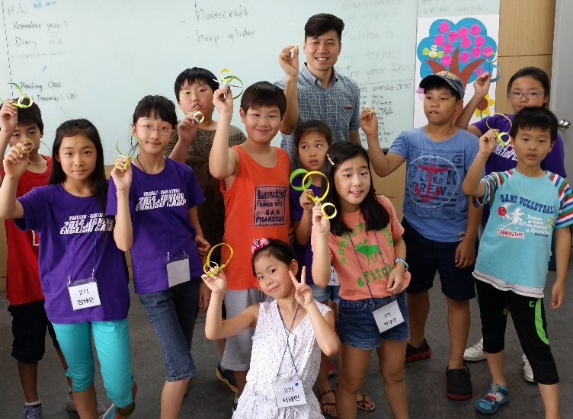 | Why?  He could be smiling for personal reasons. He’s got a lot to smile about. But this is no ordinary smile. This is a Sookmyung Kids Camp smile. Wow.

When?  Planning week is December 29th to January 2nd, minus January 1st. Teach for three weeks, Monday through Friday, January 5th to the 23rd. Nice! | 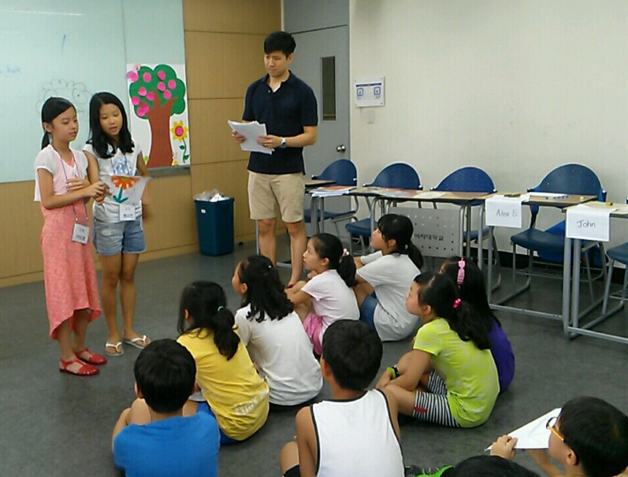

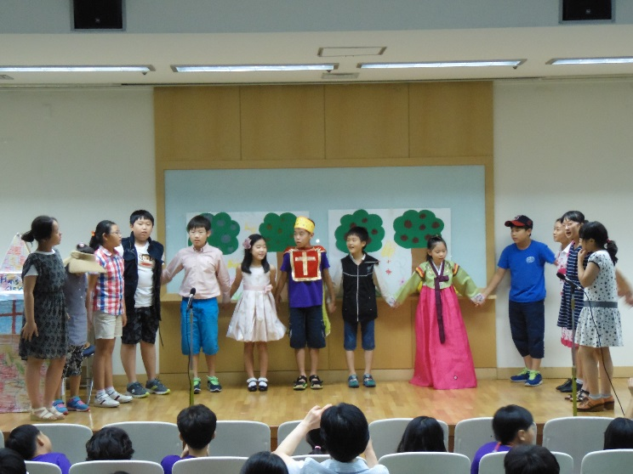 | What do I get?  You get 2,900,000 Won before taxes, a teacher’s assistant, some nifty activities to do with kids, a curriculum, and best of all, memories!! Join us!

- - - - - - - - - - - - - - - - - - - - - - - - - - - - - - - - - - - - - - - - - - - - - - - - - - - - - - - - - - - - - - - - - - - - - - - - - - - - - - - - - - - - - - - - - - - - - - - - - - - - - - - - - - - - - - - - - - - - - - - - - - - - - - - - - - - - - - - - - - - - - - - - - - - - - - - - - - - - - - - - - - - - - - - - - - - - - - - - - - - - - - - - - - - - - - - - - - - - - - - - - - - - - - - - - - - -
Who do I call? Jeany Sung at Lingua Express!
* Application Period: November 3-7, 2014
* 02-710-9165/9623, Email: shj@sookmyung.ac.kr! Yes!
- - - - - - - - - - - - - - - - - - - - - - - - - - - - - - - - - - - - - - - - - - - - - - - - - - - - - - - - - - - - - - - - - - - - - - - - - - - - - - - - - - - - - - - - - - - - - - - - - - - - - - - - - - - - - - - - - - - - - - - - - - - - - - - - - - - - - - - - - - - - - - - - - - - - - - - - - - - - - - - - - - - - - - - - - - - - - - - - - - - - - - - - - - - - - - - - - - - - - - - - - - - - - - - - - - - -
Advertisement made by Roger Fusselman, head teacher of the camp, with help from the Lingua Express staff. Special thanks to Victor Chun for the smile, Stan Lee for the sales tips, and 70s comic books for cheesy ads.
* Did you say “Lingua Express?” Then sign me up!

#2. Wanted: Teacher for Freshmen English

Program Period:
- December 15(Mon)-29(Mon), 2014(2weeks)
- February 2(Mon)- 13(Fri), 2015(2weeks)
Teaching Hours: 6Hours a Day (09:00-12:00/ 13:00-16:00)
Payment: KW40,000/Hour
Total Payment: 2.4million won
Number: 1 teacher
Application Period: November 3-7, 2014
Subjects: Communicative skills & Strategies
Prep- Courses for G-Mate Class

