Thesis for the Degree of Master

Effects of Keeping a Lexis Notebook
in Broadening Depth of Vocabulary Knowledge

by
Minji Lee

Department of TESOL
The Graduate School of TESOL and International Studies
Sookmyung Women’s University
Thesis for the Degree of Master

Effects of Keeping a Lexis Notebook
in Broadening Depth of Vocabulary Knowledge

by
Minji Lee

Department of TESOL
The Graduate School of TESOL and International Studies
Sookmyung Women’s University

Sookmyung Women’s University
Effects of Keeping a Lexis Notebook
in Broadening Depth of Vocabulary Knowledge

by
Minji Lee

A Thesis submitted to the Department of TESOL and International Studies and
the Graduate School of Sookmyung Women’s University
in partial fulfillment of the requirements
for the degree of Master

In charge of major work: Stephen van Vlack

June 2019

This certifies that the degree of master of TESOL of
Effects of Keeping a Lexis Notebook
in Broadening Depth of Vocabulary Knowledge
Minji Lee is approved by

(Signature)
Chair of Committee

(Signature)
Committee Member

(Signature)
Committee Member

The Graduate School of TESOL and International Studies
Sookmyung Women’s University
June 2019

LIST OF CONTENTS

LIST OF CONTENTS i
LIST OF TABLES iii
LIST OF FIGURES iv
LIST OF APPENDICES v
ABSTRACT vi

Chapter 1 Introduction 1

Chapter 2 Literature Review 5
2.1 Lexical Knowledge 5
2.2 Depth of Vocabulary Knowledge 6
2.3 Lexis Notebook 8
2.4 WAT(Word Association Test) 13
2.5 Word Types/Class and WATs 15
2.6 Language Proficiency and WATs 16
2.7 VKS (Vocabulary Knowledge Scale) 16

Chapter 3 Methodology 18
3.1 Overview 18
3.2 Participants 18
3.3 Instruments 20
3.3.1 WAT (Word Association Test) 21
3.3.2 VKS (Vocabulary Knowledge Scale) 22
3.3.2 Naver Dictionary App 24
3.4 Procedures 25
3.5 Data Analysis 27

Chapter 4 Results 30
4.1 Overview 30
4.2 Descriptions 30
4.3 Results of WAT and VKS 31
4.3.1 1st WAT and VKS 31
3.4.2 2nd WAT and VKS 32
3.4.3 3rd WAT and VKS 33
4.4 Individual Analysis 35
4.5 Anslysis by Word Class 40

Chapter 5 Discussion 42
5.1 Research Questions 42
5.2 Research Question 1 42
5.3 Research Question 2 44
5.3 Research Question 3 46

Chapter 6 Conclusion 48
6.1 Summaries 48
6.1 Limitation and Future design 49

References 51

Appendices 59

LIST OF TABLES
- Data collection procedures: Tests, Number of items, Time
- Target words list
- The number of responses to noun, verb, adjective, and adverb
- The number of responses to repeated words

LIST OF FIGURES
1. Age variation and gender of participants
2. Illustrates of an example of WAT
3. Illustrates of an example of VKS
4. Example captured screen of naver dictionary application
5. Categories for analyzing associates
6. Five scales of VKS
7. Results of 1st WAT
8. Results of 1st VKS
9. Results of 2nd WAT
10. Results of 2nd VKS
11. Results of 3rd WAT
12. Results of 3rd VKS
13-28. Personal Results (Student 1 to 16)

LIST OF APPENDICES
1. Template of lexis notebook
2. Template of 1st WAT
3. Template of 2nd WAT
4. Template of 3rd WAT
5. Template of 1st VKS
6. Template of 2nd VKS
7. Template of 3rd VKS

ABSTRACT

Effects of Keeping a Lexis Notebook
in Broadening Depth of Vocabulary Knowledge
Minji Lee
Department of TESOL
The Graduate School of TESOL and International Studies
Sookmyung Women’s University

As vocabulary learning is both an essential and complex activity for students and language teachers, it is quite a challenging thing to choose an effective way of teaching vocabulary beyond the simple acquisition of form and meaning of the word itself. Since the Korean learning context often values only the breadth of vocabulary knowledge, in the form of simple translation, students hardly experience development of vocabulary depth. As a result, the present study aims to examine the effects of keeping a lexis notebook on broadening the depth of vocabulary knowledge of sixteen 6th to 9th grade Korean students. The participants’ depth of vocabulary knowledge was estimated using techniques called a WAT and a VKS three times, including a pre-test, mid-test and post-test. The results of this study show some positive effects of keeping a lexis notebook in broadening students’ depth of vocabulary knowledge despite some slight changes. Students also were found to have produced more cognate relations after keeping lexis notebooks. The tendencies of students to produce schematic and cognate words gradually and responding more to cognate associates of verbs than other word types were found as well.
▬▬▬▬▬▬▬▬▬▬▬▬▬▬▬▬▬▬▬▬▬▬▬▬▬▬▬▬▬▬▬
Key words: Depth of vocabulary knowledge, Lexis notebook, Word association test

Chapter 1. Introduction

According to Benzitoun and Kaouache (2017), it is common for students to think that once they learn one meaning and spelling of a word, the job of learning that word is done. However, this process is just the first step in vocabulary learning based on numerous, diverse studies. As Kang, Kang, and Park (2012) asserted, vocabulary knowledge is vital even from the beginning of language learning, as without it, these learners cannot process and comprehend meanings of even simple sentences or clauses. Shmitt (2006) identified that vocabulary learning is incremental, as the mastery of vocabulary is gradual and a language learner needs to be exposed to vocabulary items many times (Schmitt, 1998, 2000, 2010). According to Alharthi (2014), mastery of second language vocabulary item requires the learner to be exposed to a complicated process of engaging in comprehensive understanding of different aspects of vocabulary knowledge such as form, meaning, and use (Schmitt, 2000).
Vocabulary, however, cannot be simply defined as just single words, but they can be related to each other in various ways. It has been mentioned that learners are often confused in second language acquisition, due to their lack of vocabulary knowledge of various dimensions/types of words such as syntactic, semantic, and pragmatic properties (McKeown & Beck, 2004). Nation (1990, p.31) also presented a list of the word knowledge types that native-speakers typically have; a word's spoken form, a word's written form, a word's part-of-speech, derivative forms, grammatical patterns, collocations, how frequently a word is used in a language, many stylistic constraints which determine if a word is appropriate in a particular context, a word's conceptual meaning, and a word's semantic network of associations. The assumption is made that if EFL learners aspire to native-like proficiency in the use of words they must not merely be able to know L1 translations of the words, but also know when and how to use those words in context. As many researchers have asserted, development in vocabulary knowledge is not a simple construct, and researchers have focused on two types of lexical knowledge; breadth and depth.
Read (2000) and Vermeer (2001) explained vocabulary knowledge as a mixed-contracture of two dimensions of breadth and depth of vocabulary knowledge. Although these claims have been defined in different ways (Nassaji, 2004; Qian, 2002; Zareva, 2005), a general definition breadth of vocabulary knowledge represents one’s vocabulary size, or approximately how many words one knows. In contrast, the depth of vocabulary knowledge indicates the quality of one’s knowledge of words which is to say how well one knows a specific word or a set of words. Since the Korean learning context often values only the breadth of vocabulary knowledge, meaning the simple translation/definition of targeted words, students insufficiently experience development of depth. Due to the difficulty in learning, various factors have been noticed as the focusing point in developing depth of knowledge, such as word families. A word family is a group of words that share a common base to which different prefixes and suffixes are added; e.g. for word- words, reword, wordy, wordless. According to Onysko and Michel (2010), language users are able to analyze complex words and to establish synchronic relations between words both formally and semantically because they have an implicit or even explicit knowledge of word-family organization. Through learning word family, learners can decode many new or unfamiliar words through understanding what different prefixes and suffixes do to a root word without learning them individually (Onysko & Michel, 2010).
Since vocabulary learning is both an essential and complex activity for students, for language teachers, it is quite challenging to choose an effective way of teaching vocabulary over simple acquisition of form and meaning of the word itself. It has been insisted that teaching vocabulary should not only consist of acquisition of specific word, but also aim at helping learners with the learning/teaching methods that are necessary to expand their vocabulary knowledge (Morin & Goebel, 2001). While a ‘Lexis notebook’ may contain various aspects of lexical knowledge; such as word families stated above, they were originally brought up merely as means of exposing the learners to various methods of recording vocabulary (Fowle, 2002). According to Khanmohammad and Homayoun (2014) as well, lexis notebooks can be learning tools that learners use to record elements that improve their learning of new and useful vocabulary items. As McCarthy claims that “The very act of writing a word down often helps to fix it in the memory” (McCarthy, 2007), and learning through a lexis notebook is categorized as a cognitive strategy within the larger division of consolidation strategies. However, there have not been many studies conducted that teaching depth of vocabulary knowledge by using a lexis notebook, especially focusing on word families. Moreover, a word association test is not generally used with young learners as a mean of checking their progress regarding depth of vocabulary knowledge due to the language proficiency. To this end, examining the findings and limitations listed above, the present study thus aims to examine the effects of keeping a lexis notebook on broadening the depth of vocabulary knowledge, and to that end conducted research with sixteen Korean middle school students. The mixed method research design was applied to this study to investigate whether students showed progress in their depth of vocabulary knowledge. Due to the participants’ academic context as Korean middle school students, they could only participate in academy work for two hours a week, and the period of conducting the study was be short and designed as a low-intensity form of practice with the following research questions;

1. In what way does working with a lexis notebook change the vocabulary knowledge of students?
2. How does word class/type affect changes in vocabulary knowledge?
3. How do association types differ among participants?

Chapter 2. Literature Review

2.1 Lexical Knowledge
Through the years, vocabulary researchers have defined the nature of word knowledge and its different dimensions of word knowledge in a list of considerations. Verhallen (1994) suggested a few lexical categories, which can be produced on WAT, including paradigmatic relationship (subordinates; super ordinates; synonyms, e.g. animal/dog, plant/flower/rose, or fast/quick), syntagmatic relationship (definitional aspect of a word and possible collocations, e.g. furniture/desk), partonomic relationship (part-whole relationship, e.g. banana/peel), conceptual relationship (e.g. banana/yellow), cognate relationship (words in the same word family that are often related semantically, perceived as having a same root or being cognate forms, e.g. photo/photograph/photography). Richards (1976) similarly asserted that word knowledge should be defined by syntactic characteristics, associations, constraints, semantic value, usages, different contextual meanings, morphology, and underlying form and derivations. Nation (1990), suggested eight types of word knowledge including; 1) the spoken form of a word 2) the written form of a word 3) the grammatical behavior of a word 4) the collocational behavior of the word 5) the frequency of the word 6) the stylistic register constraints of the word, 7) the conceptual meaning of the word and 8) the associations the word has with other words. Based on these three studies by Verhallen (1994), Richards (1976) and Nation (1990) this study will also parse vocabulary into eight specific categories.

2.2 Depth of Vocabulary Knowledge

Vocabulary knowledge has been identified as one of the major contributors to reading comprehension (Bauer & Arazi, 2011; Braze, Tabor, Shankweiler, & Mencl, 2007; Freebody & Anderson, 1983; Pae, Greenberg, & Williams, 2011; Proctor, August, Carlo, & Snow, 2005; Tannenbaum, Torgesen, & Wagner, 2006; Thorndike, 1917a/1971, as cited in Kang, Kang, & Park , 2012, p.3).
According to Choi (2013), breadth of vocabulary or vocabulary size represents the number of words known, while depth of vocabulary indicates how well one knows a word. Choi (2013) goes on to say that depth of vocabulary knowledge ranges of a partial understanding of a word to full mastery of several aspects of a given word including its related meanings and appropriate uses in specific contexts(Kieffer & Lesaux 2012, Qian 1999), while breadth of vocabulary knowledge represents the number of vocabulary items known for which a language learner has at least minimum knowledge of their meanings.
Li and Kirby (2015,) suggested that breadth/size of vocabulary can be defined as “knowing the oral and written forms of the words, the surface meanings, and basic uses of the words” (p. 612). Qian (1999, 2002) insisted the importance of knowing the meaning of words and regarded vocabulary size as the number of words for which language learner has at least some superficial knowledge of meaning. Generally, in investigating the relationship between reading comprehension and vocabulary knowledge, vocabulary knowledge has been estimated by breadth, which is determined by the size of learner’s receptive vocabulary knowledge. Various past studies have also demonstrated that one's vocabulary breadth strongly affects reading comprehension ability (Beck & McKeown, 1991; Freebody & Anderson, 1983; Nation, 2001; Pasquarella, Gottardo, & Grant, 2012; Torgesen, Wagner, Rashotte, Burgess, & Hecht, 1997; Verhoeven & van Leeuwe, 2008, as cited in Kang, Kang, & Park , 2012, p.4). According to Hirsh and Nation (1992), to be able to read a complex text in English for pleasure, the reader needs a vocabulary size with a breadth, of around 5,000 words. Nation (2006) suggests that EFL learners need a vocabulary size between 6,000 and 7,000 for listening, and 8,000 and 9,000 for reading. Similarly, in order for a language learner to begin reading authentic texts, a vocabulary size of 3,000 words is regarded as the basic threshold, and 5,000 words will be enough to be able to read them (Schmitt, Schmitt & Clapham, 2001). Another claim is that native speakers of English have around 20,000 words at their disposal (Goulden, Nation & Read, 1990). For non-natives, a vocabulary knowledge of around 10,000 words in English is considered as a requirement for university education (Hazenberg & Hulstun, 1996). However, these figures should be regarded with precaution, especially for foreign language learners because their vocabulary sizes are not stable and may fluctuate because although some lexical items are known at one point and in time these might be forgotten (Meara & Rodriguez, 1993).
Comparing to that, vocabulary depth reflects accurate knowledge of words, and it has been identified as an important predictor of reading comprehension abilities (Muter, Hulme, Snowling, & Stevenson, 2004; Nation & Snowling, 1998, 2004; Ouellette & Beers, 2010; Roth, Speece, & Cooper, 2002; Tannenbaum et al., 2006). As Qian (1999) asserted, the depth of knowledge should cover multiple components such as pronunciation, spelling, meaning, register, and frequency, as well as morphological, syntactic, and collocational properties. Most lexical researchers seem to accept that those two areas of breadth and depth tap different dimensions of vocabulary knowledge (Read 2000, Tannenbaum, Torgesen, & Wagner 2006), whereas some conflicting argument appear in the literature as to whether this dichotomous distinction between the breadth and depth is valid (Kieffer & Lesaux, 2012)
Nation and Snowling (2004) focused on the predictive role of depth of vocabulary knowledge which was evaluated by an exercise of meaning aspect for the improvement of academic reading comprehension. The results from L2 vocabulary research gave evidence that a distinct relationship existed concerning depth of vocabulary knowledge and L2 proficiency.
Razmjoo and Kian (2011) examined the similar issues in a different context, i.e., an EFL context. Their findings showed that depth of vocabulary knowledge proved to have greater influence over the academic reading proficiency of the students from a university in Iran than breadth of vocabulary knowledge. In the Korean EFL context, Kang, Kang, and Park (2012) found that in comparison with breadth of vocabulary knowledge, vocabulary depth worked as more significant predictor to reading comprehension of Korean high school students.

2.3 Lexis notebook

Even in the basic form of simply recording an entry, the vocabulary notebook is found to be helpful to the learner, as McCarthy (as cited in Kim, 2009, p.188) claims, “The very act of writing a word down often helps to fix it in the memory”. In detail, as mentioned by McCrostie (2007), a common vocabulary notebook format includes the form of the L2 entry along with an L1 equivalent and an example sentence; L2 definitions are left optional. While some vocabulary notebooks may contain other aspects of lexical knowledge, as demonstrated in Fowle (2002), they were brought up merely as means of “exposing the learners to various methods of recording vocabulary” (Cited in Kim, 2009, p.189). Keeping a vocabulary notebook is categorized as a cognitive strategy within the larger division of consolidation strategies.
Bozkurt (2007) studied the effects of vocabulary notebooks on vocabulary acquisition, especially on pre intermediate level of English learners, and some attitudes of both teachers and learners on keeping vocabulary notebooks. Data was gathered through vocabulary testing to show the progress and group interview was taken as well to both teachers and students. According to the study, the experimental group, students who studied with vocabulary notebooks showed better vocabulary acquisition compared to the control group based on the normal curriculum. Students also developed their autonomy towards studying and productivity of using words. Bozkurt also stressed the need for applying words that students recorded in their notebooks during the language class so that they could have real contextual practice with the lexical items.
Kostova, Minkov and Tsvetkov (2013) found a similar case with students of Bulgarian medical universities. During the experimental period, foreign students used Bulgarian-English training dictionaries, which they used to organize English technical terms into Bulgarian language and even derivatively related forms. The results showed that keeping this notebook was beneficial for foreign students to learn something in another language and this can be not only a handbook, but also a mediator in communication. Based on this, the positive impact of keeping a lexical notebook can be linked to the expectation of future experimentation even though the focus contents and students may then be different from the plan of their current study. Moreover, as it is mentioned in other studies as well, teachers should consider in keeping students’ focus on the activity since it is very time-consuming work.
Arab (2015) studied the usefulness of the lexical notebook as a vocabulary learning strategy and its’ positive impact on vocabulary acquisition with the first-year, secondary school EFL students with low proficiency in English. Students and teachers were required to fill in two types of questionnaires, pre/posttest, to see the progress. Arab quoted the arguments of many researchers regarding how keeping vocabulary notebooks is considered as a useful vocabulary learning strategy since note taking has the benefit of increasing learners’ attention, makes learners get involved in the lesson while recording the remarks, preserves the recorded information for later use, and serves learners in revising and preparing for their exams. Based on this finding, the study may support that learning with lexical notebook enhance not only vocabulary acquisition but also writing skill as well by using words in appropriate form for the right context they learned through activity.
Ferris (2012) conducted a study showing the importance of teaching vocabulary and suggested ways in which common classroom methods and published materials could be used to learn vocabulary. Ferris claimed the fact that students understand what a word refers to allows them to use it in a grammatically accurate way and it is directly related to the development in proficiency level as a result. Also, according to the paper, keeping handy lexis notebook with a translation of a sentence containing the lexis, idioms, phrasal verbs or any other longer and more complicated bits of lexis is suggested as one of the ways of encouraging a systematic approach to recording lexis.
Hofman (2016) studied about the influence of lexical notebooks on primary school learners’ vocabulary learning and found that there is improvement in terms of vocabulary learning. 18 fifth grade students were selected as participants and were divided into an experimental group learning with lexical notebooks and a control group learning with traditional learning strategies similar to what most Korean students learn. They were asked to fill in three types of questionnaires, one per month. Semi-structured interviews were performed to find how and why an intervention occurred during the activity, and pre/posttest were performed to gauge the improvement on grammar and vocabulary. The study proved that the lexical notebook influenced students’ learning of vocabulary, memory strategies, and autonomy in a positive way compared to the control group of students. Hofman (2016) pointed out that students might be passive or lethargic when using lexical notebooks for the first time, and thus, it is important to consider motivation as well.
Khanmohammad and Homayoun (2014) compared the effects of keeping lexis notebooks and vocabulary notebooks, which is writing down words with definitions and memorizing them as is commonly done in the Korean school environment. This study was performed regarding students’ vocabulary learning with intermediate level English learners. 60 intermediate level students, aged 17 to 20 were selected as participants. Data was collected by questionnaires to see if the attitudes of students towards research were positive. Pre/posttests were also given to see the progress in vocabulary learning. Even though the use of a vocabulary notebook was found to be helpful, the results showed that keeping a lexis notebook was more effective than keeping a vocabulary notebook on students’ depth of vocabulary learning. Moreover, it was shown in the questionnaire that students have more positive attitudes toward keeping lexis notebooks than keeping vocabulary notebooks.
Bofman and Vamarasi (2006) studied the effects of the lexical approach on teaching Thai and Indonesian students. This used the lexical approach, which maintains that the teaching fixed phrases, idioms, strong collocations, semi-fixed expressions, and chunks is not only beneficial to improve students’ accuracy and fluency in English, but also in any other languages. They suggested lexical notebooks as one way of teaching with the lexical approach that can constantly develop a record of what the student is exploring about the language in a bilingual list. The focus language of this study was different, but still implies an influence of lexis notebooks on learning across various languages including English and Korean.
D’Onofrio (2009) compared two different types of vocabulary notebooks, one focused mostly on definitions, as is done in Korea, and another that engaged learners in creating personal knowledge links with ESL students. Thirty 10th grade ESL students participated in three types of tests: a pre-test, mid-test and post-test. The test was intended to determine how clearly students know about focus words. Unexpectedly, the results of study showed that there was no significant difference between two templates among the students and they found both of them to be useful and easy to use. In addition, students participated in the work more actively when they were asked to use the words based on their interest irrespective of the visible results. The result of this study was different from the other studies above, however, this continues to reinforce the need for a deliberate choice of words based on students’ interest in order to ensure students’ continued participation.
Alexiou and Konstantakis (2009) explored if vocabulary is used in a number of recent course books overlapped with the first two thousand most frequent words in English based on data from General Service List (GSL) and the British National Corpus (BNC). Since choosing what to teach is a significant factor as well, this study gives clues as to the current state of the art. For data collecting, frequent types of word used in coursebook for the first-grade students were analyzed. As a result, the study showed that there was a great variety in the number of new words presented in beginner level course books although mostly they came from the 2,000 most frequent words. However, there were notable quantities of infrequent vocabulary also used in order to draw interest from various types of young learners. This implies that words presented for young beginners should be both common and demanding at the same time in order to help in develop their vocabulary proficiency and focus their concentration. Based on these findings, the process of choosing words (word families) considered frequency but also interest as one can learn a set of words come from one root word without learning them individually through word family.
Fadel (2011), explored the relationship between middle school teachers’ techniques and the strategies intermediate level students use in order to deal with new vocabulary. As a mean of data collection, questionnaires were given to both teachers and students twice, before and after the activity. According to the study, teachers’ teaching techniques often did not match their students’ different learning styles because individual learners present many differences since they all have different kind of intelligence. Fadel (2011) also stressed why it is so important to choose a teaching strategy carefully in order to have better result in students’ learning such as, using lexis notebooks as an alternate way of helping students who have difficulties in learning new vocabulary with traditional teaching strategies. Moreover, based on the results, it has been asserted that only writing a definition (translation) of a word is not a good way of learning words. Since it is very common for Korean students to organize newly learned vocabulary only with their translations, keeping a lexis notebook could be an alternative way of learning, especially for those who cannot fit into traditional methods based on the findings of Fadel’s study.

2.4 WAT (Word Association Test)

WATs (Word Association Tests), which were invented by Galton, are a technique used to test which associated words people produce and it has been widely used in psychology by psychiatrists such as Jung, Kent and Rosanoff, whose study was the first large scale study which was carried out in English with 1,000 men and women(as cited in Istifci, 2010, p.2 ). In the study, 100 targeted words were used and participants read one word at a time to a person who was required to produce the first word that came into his/her mind. Based on the resulting data, it was asserted that there was a uniform/common tendency in the organization of associations and people shared stable networks of connections among their vocabularies.
According to Bahar and Hansell (2000), word association tests are one of the most common and oldest means for studying the cognitive structure of a person and this has been used widely by several researchers. The implicit assumption in a word association test is that the sequence of the response retrieval from long-term memory reflects at least a significant part of the structure within and between concepts. Bahar and Hansell (2000) added that the degree of overlap of response hierarchies is a degree of the semantic proximity of the stimulus words in a word association test.
Agdam and Sadeghi (2014) measured depth of word knowledge in 82 elementary and 71 advanced EFL learners to explore which format was better for assessing deep word knowledge for each group using both selective and productive WAT tasks. Results have shown that elementary learners did better in selective format while advanced learners reacted better in productive format. Espinosa’s (2009) study analyzed young learners’ L2 association responses with a word association task as well and the results have supported the view that the organization of the lexicons of L2 young learners was predominantly meaning-based, due to the tendency of an overwhelming majority of responses based on meaning relations, such as syntagmatic and paradigmatic, and a minimal proportion that are in the clang category.

2.5 Word types/Classes and WATs

Nissen and Henriksen (2006) conducted a study to investigate the influence of word class on word association test results in both the L1 and L2. The resulting data showed that word class types affect test results, for example, “nouns elicit a higher proportion of paradigmatic responses than verbs and adjectives. The influence of word class on test results is discussed in terms of the acquisition and semantic organization of nouns, verbs and adjectives” (p.20). They asserted in addition that “the result leads to a critical discussion of the concept of the syntagmatic–paradigmatic shift, which in the light of the test results in this study is seriously challenged” (p.20)
Read (1993) carried out a study with university students in the English department and tested their knowledge of academic words. Read’s test involved with a target word followed by eight other words, four of which are semantically related to the target word, and four of which are not. Read (1993) had a purpose to assess receptive word knowledge and knowledge about the meaning of a word, the words with which it is associated, and the collocations in which it occurs. Read (1993) distinguished three types associations based on preliminary drafting of items: 1. paradigmatic (The two words are synonyms or at least similar in meaning, perhaps with one being more general than the other), 2. syntagmatic (The two words are collocates that often occur together in a sentence); 3. “The associate represents one aspect, or component, of the meaning of the stimulus word and is likely to form part of its dictionary definition” (p.359).

2.6 Language proficiency and WATs
Istifci (2010), in different way form Nissen and Henriksen (2006), conducted the study using word associations of elementary to advanced level of EFL learners through a 20-item Word Association Test to see whether there are differences or similarities between the data from the students in these groups. As a result, it was seen that there were some differences or similarities between groups. Based on the data collected, it was asserted that EFL learners try to use a wide range of word association techniques and the proficiency level of the students have a partial effect on their use of word associations (Istifci, 2010). This can support the idea of differences of produced words which can be related to the proficiency level of students.
Randal (1980), den Dulk (1985) and Kruse et al. (1987) (as cited in Wolter, 2002) tried to demonstrate a link between proficiency and responses on a multiple response word association test. They claimed that a WAT could function as a means of assessing proficiency. Wolter’s (2002) study showed, however, that word associations in a foreign language are not clearly linked to proficiency.

2.7 VKS

Paribakht and Wesche (1997) created the Vocabulary Knowledge Scale (VKS), which is the most widely accepted measure of vocabulary depth. The VKS includes a five-level elicitation scale for self-reporting and demonstrating vocabulary knowledge, and a corresponding five-level set of scoring categories (Wesche & Paribakht, 1996, p. 30.) The VKS is a developmental scale used to assess ESL learners' 'incidental’ acquisition of meanings of target words.
According to Elmasry (2012), the VKS also combines both receptive and productive knowledge of specific targeted words. This means, in other words, test takers are expected to produce a potential sentence with the stimulus word and therefore the VKS is a deep and multi-faceted scale.
According to Paribakht and Wesche (1993), the VKS is capable of measuring progress in the developing knowledge of particular words and of showing intra-group change as well as inter-group differences in gains of content vocabulary resulting from a brief instructional period.

Chapter 3. Methodology
3.1 Overview
The main objective of this study is to analyze the effects of learning vocabulary through lexis notebooks focusing on word families in order to broaden depth of knowledge in the ESL/EFL background context. The mixed method research design was applied to this study to investigate whether students showed progress in the development of the depth of their vocabulary knowledge. In this chapter, the participants of the study, main instruments, procedures, and overall criteria of data analysis will be discussed.

3.2 Participants
The participating students included a sample of 18 Korean students in the 6th grade to 9th grade from an elementary school, and two different middle schools in Seoul, South Korea. The participants were consecutively selected in order of appearance according to their accessibility. Considering the level of the WAT and VKS, students of the academy who had an English proficiency that was deemed too low to answer were excluded, and 18 students remained as the participants. Since all the participants go to the same English academy, this research was mainly taken during the classes in academy and most of the lexis notebook work was given as homework. According to the background questionnaire, the average age of students was approximately 14.6 years old. None of the students had experiences living in English-speaking countries, and had only studied English for 2-6 years inside of Korea.

Figure 1. Age variation and gender of participants
The sample was nearly balanced in terms of gender (44.4% female; 10 male and 8 female students in total). Based on their scores on several preparatory examinations for the school/academic English Ability Test, fifteen of the students were fairly motivated towards their academic achievements and had intermediate proficiency level in English reading. The other three participants in the pre-intermediate proficiency level of English had some difficulties in learning school subjects including English. After the pre-test and a month-long process of keeping a lexis notebook, two students (not the ones who had learning difficulties) quit the academy, thus a total of 16 students remained and participated until the end of the experiment. Two 7th grade students were excluded in the later data since they participated only in the pre-test. In addition, six of 8th grade joined kept lexis notebook a month later than others in order to focus on their school examinations.

3.3 Instruments
The design of the current research, which is to investigate whether students show progress in their depth of vocabulary knowledge, was motivated by a simple pilot study held in corpus linguistics class in 2018 and Arab’s (2015) study. The pilot study from the corpus linguistics class basically demonstrated the influence of cultural background and testing by WAT (word association test) and Arab’s study showed the usefulness of lexical notebooks as a vocabulary learning strategy and its’ positive impact on vocabulary acquisition with first-year secondary EFL students. The Word Association Test (WAT), the main task used in this study, invented by Galton (1879) was intended to measure how well learners knew words. Instead of estimating the broadness of the learners’ word knowledge, the WAT assesses how deeply students know about the various relationships between the stimulus/targeted word and other words. Unlike other formal methods, which were used in the corpus study as well, the word association test was used only to explore the changes in the mental lexicon regarding the depth of vocabulary learning in this study.
The overall theme of Arab’s (2015) study was similar to this paper, however the instruments applied were partly different from the ones used in Arab’s (2015). The present study, in estimating the depth dimension of vocabulary, used an adaptation of the Word Association Test originally invented by Galton (1879), and the Depth of Vocabulary Knowledge Test (DVK) adjusted by Qian (1998). Pre-test was held on 15th of November, 2018 and students were asked to begin studying vocabulary by keeping a lexis notebook. A template was made and given with the categories of target word (base form), related words, example sentences, synonyms, antonyms, and translations in Korean. To shorten the time for doing lexis notebooks, Visuwords (https://visuwords.com/) was first considered as a guiding tool for lexis notebooks. However, students found it difficult to use the website because its language setting is fully in English, which was prohibitory considering the level and age of target students. Alternatively, the phone application Naver dictionary (네이버사전) was used as an additional tool, so that students can easily find out what to write about the targeted words in a short amount of time, especially the related forms and example sentences.

3.3.1 WAT (Word Association Test)
Word Association Tests, which were developed by Galton (1879), are tests used in order to estimate the associations people make between words and it has been widely used in psychology by psychiatrists in the first place such as Jung, Kent and Rosanoff. Kent and Rosanoff’s study was the first large scale study which was applied in English with 1,000 men and women (Istifci, 2010).
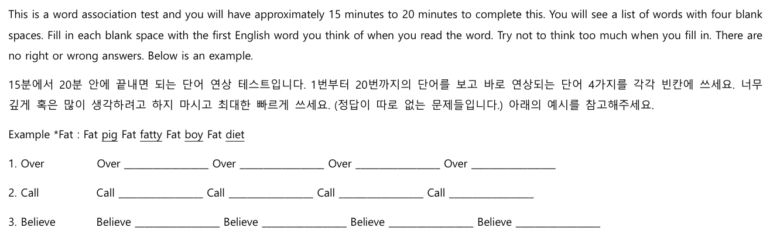
Figure 2. Illustrates an example of WAT
As mentioned above, unlike the formal use of word association tests to find out how deeply people know the various relationships of the targeted word with other words, word association tests are used for seeing the changes in the mental lexicon in the depth of vocabulary learning in this study. Thus, the participants’ depth of vocabulary knowledge was estimated by a technique called WAT (Word Association Test), which was comprised of 20 multiple-choice questions that carefully chosen out of the original target stimulus words for three times, including pre-test, mid-test and post-test. (Refer to Appendix B) The number of questions was decided as an upper limit for participants considering their English proficiency level and age. All the questionnaires and tests were written out for the ease of data collection and analysis and students’ levels of English were considered as part of the decision regarding the number of questions. The selection of target words was based on the words list from students’ school textbooks and word frequency data from (https://www.wordfrequency.info/free.asp?s=y). All the words used through the experiment were both in students’ textbooks and the Corpus of Contemporary American English (COCA) list of 500 most frequent words. Furthermore, vocabulary items believed to be unfamiliar to most of the participants were excluded. All the tests were provided to participants as a written test to generate permanent, easy to process data considering the low language proficiency of students.

3.3.2 VKS (Vocabulary Knowledge Scale)
The Vocabulary Knowledge Scale (VKS), invented originally by the researcher based on a five-set Vocabulary Knowledge Scale (Wesche & Paribakht 1996), was developed to discover if the participants know the meanings/concepts and uses of conjugated words based on the ones from the targeted words of lexis notebook. This test measures small gains in knowledge in order to compare the effectiveness of different vocabulary instructional skills. The VKS utilizes the idea of vocabulary depth, “the idea that there are many different aspects to knowing a word and that vocabulary acquisition means gradually building up more extensive knowledge of items” (Brown, 2008). The VKS thus allows students to demonstrate partial knowledge of items, which can measure vocabulary gains.
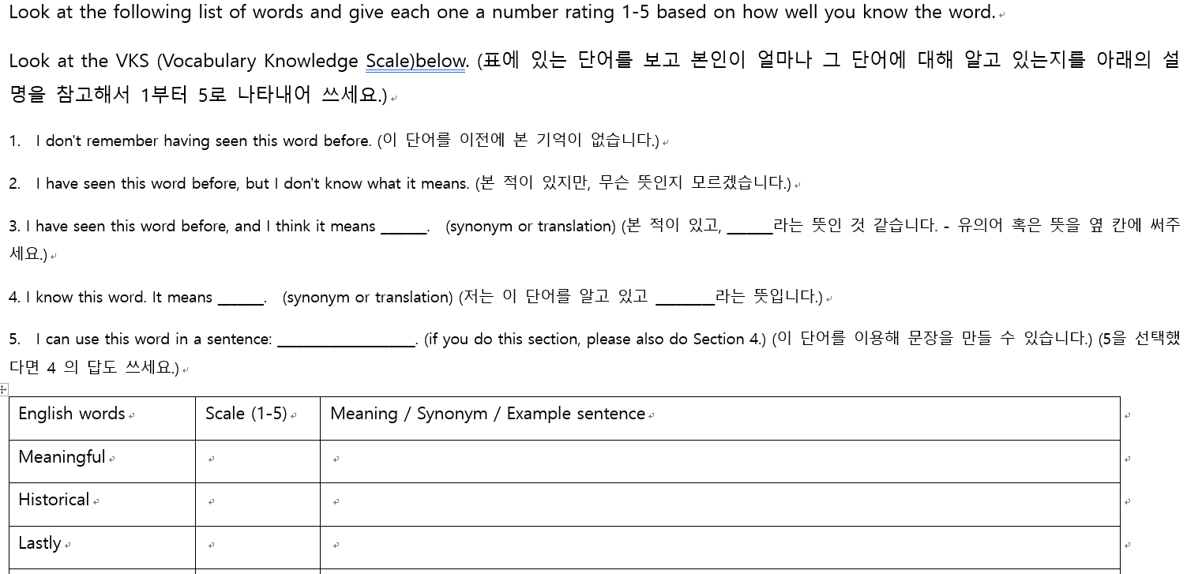
Figure 3. Illustrates an example of VKS.
The most basic goal of VKS used for this study was the same as the traditional way, however, only the conjugated/related form of words that students learned by lexis notebook were used to show whether the depth of vocabulary knowledge of the students improved by keeping a lexis notebook. Students were asked to self-score whether they knew the meanings of the tested words based on the scales of 1 to 5. (Scale 1. I don't remember having seen this word before. Scale 2. I have seen this word before, but I don't know what it means. Scale 3. I have seen this word before, and I think it means _______. Scale 4. I know this word. It means _______. Scale 5. I can use this word in a sentence.) They were, then, required to write definitions/translations in Korean, once they had marked the item with anywhere from 2 to 5. For the WAT as well, this process was undertaken three times, as a pre-test, mid-test, and post-test.
3.3.3 Naver Dictionary App
The application, Naver Dictionary (네이버사전), supports 34 languages, including English, Korean, Chinese and many other languages. 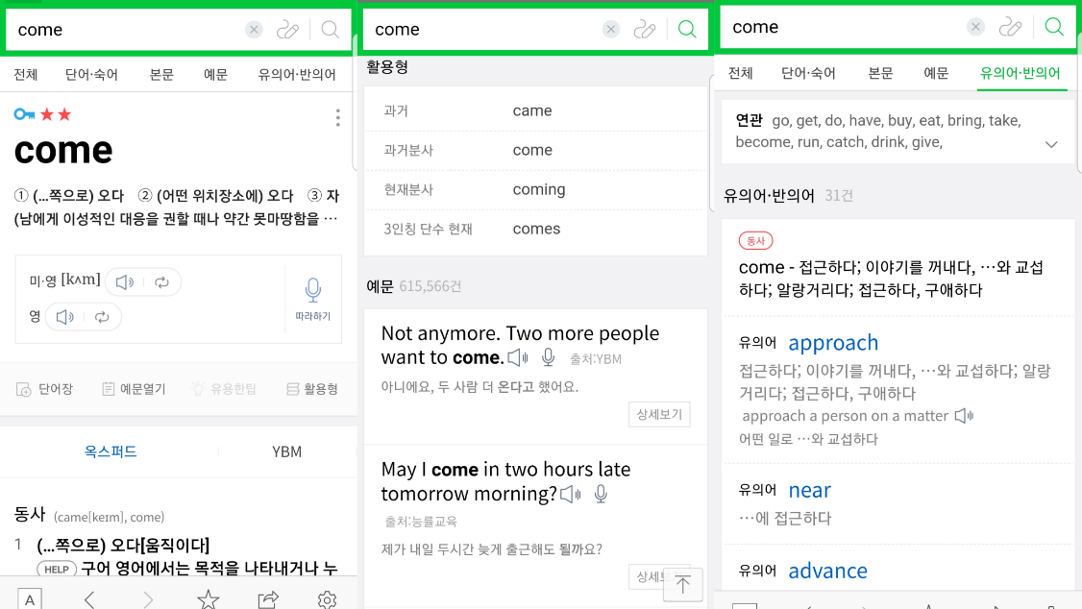
Figure 4. Example captured screen of Naver dictionary.
By using this phone application (even without log-in), students were asked to complete six lexis notebooks each week with targeted words given by an instructor. All the words were carefully chosen by a teacher on the basis school materials and word frequency data. The procedure/method of using the application was carefully demonstrated to the students by showing the example word ‘come’, which was one of the targeted words. It was required that students search for the targeted word using the Naver dictionary application prior to all the following processes. After getting results, they were then asked to find data correlates to the categories in the lexis notebook; Meaning, Related forms, example sentences, synonyms, and antonyms. Since all the students were fully aware of how to use various phone applications already, none of them had difficulty engaging in this process. Moreover, Naver dictionary was considered as the proper tool for Korean students learning English at this age and skill level.

3.4 Procedures
The whole process started on the 15th of November, 2018 and ended on the 7th of February, 2019. After the pre-test and mid-test, keeping a lexis notebook was required of the students, thus, in entirely a two-month of process of keeping lexis notebook was given to all the participants until the date of the post-test.
Session | Tests | Number of items | Time (Min)
1 | WAT | 20 | 20
1 | VKS | 7 | 5
2 | WAT | 20 | 20
2 | VKS | 7 | 5
3 | WAT | 20 | 20
3 | VKS | 7 | 5
Table 1. Data Collection Procedures; Session, Tests, Number of Items, Time (min)

Target word list
1. Find | 11. Try | 21. Through | 31. Mean | 41. History
2. Come | 12. Large | 22. Believe | 32. Place | 42. Result
3. Go | 13. Happy | 23. When | 33. Move | 43. New
4. Final | 14. True | 24. After | 34. Point | 44. Different
5. Use | 15. Month | 25. Call | 35. Hold | 45. High
6. Actually | 16. Be | 26. As | 36. Happen
7. Just | 17. Case | 27. Last | 37. Power
8. Great | 18. Look | 28. Feel | 38. Bad
9. Real | 19. Even | 29. Own | 39. Allow
10. Able | 20. Over | 30. Leave | 40. Sure

Table 2. Target words list
Three vocabulary measures were administered across two testing sessions each time: a WAT and VKS were administered at monthly intervals. Unlike the mid-test and post-test, students were asked to do a sample WAT in Korean before doing the WAT and VKS as a practice during the pre-test. (This is not included in data analysis.) For the first week doing the lexis notebook, students were only required to do three focused words in the lexis notebook to learn how to fill in the templates. All of them downloaded the naver dictionary application on their phone under the teacher’s guidance. After that, students were asked to submit their notebooks each week for four weeks, and a mid-test was taken to see the progress in the depth of vocabulary knowledge, especially by conjugated/related forms of target words. This process was repeated for four weeks again until the post-test. The lexis notebooks made by students were collected every week by the instructor and students who lost their paper or did not finish homework were asked to continue it before the class started in the academy. Consequently, all the lexis notebooks were collected without any missing data and were analyzed after the post-test was held. All measures were timed and administered for students by a teacher and instructions were clearly explained. The time set for each measure was carefully determined on the basis of the results from the pilot studies. Among the 16 students (excluding the two who quit the academy a few weeks after the pre-test), six of the 2nd grade students started using lexis notebooks a month later (right after the mid-test) than others because of the preparation for the school examination. Words from 1 to 22 were given as targeted ones after the pre-test, 23 to 45 were given after the mid-test. To recognize changes in students’ vocabulary knowledge, “Find”, “Believe”, “Able”, and “Over” were selected and used twice in the WAT, once before it was given as a homework and once after students wrote them on lexis notebook. Due to their low language proficiency, they had difficulty in filling all the blanks on the WAT. For the VKS, however, students seemed better able to respond to the targeted word since they were only required to scale themselves by number. Even those who had answered with a scale 5, which required them to make their own example sentences using stimulus words, did not need much time to respond.

3.5 Data Analyses
The main purpose of the present study was to find out:
1. In what way does working with a lexis notebook change the vocabulary knowledge of students?
2. How does word class/type affect changes in vocabulary knowledge?
3. How do association types differ among participants?
Descriptive and inferential statistics were analyzed including the reliability coefficients for all the measures. In answering the research questions, these mixed categories suggested by Verhallen (1994) and Richards (1976) were partly carried out and mixed for analyzing produced words;
1. Paradigmatic relationship (subordinates; super ordinates; synonyms, e.g. animal/dog, plant/flower/rose, or end/finish, fast/quick)
2. Syntagmatic relationship (definitional aspect of a word and possible collocations, e.g. furniture/desk)
3. Partonomic relationship (part-whole relationship, e.g. banana/peel)
4. Conceptual relationship (e.g. banana/yellow)
5. Cognate relationship (words in the same word family that are often related semantically, perceived as having a same root or being cognate forms, e.g. photo/photograph/photography)
6. Phonological relationship (words of pairs of sounds, e.g. beat/bead, back/bag, race/raise, cry/try, feel/peel)
7. Schematic relationship (Based on personal background knowledge)
8. Undefined (random words that cannot be defined into certain categories)
Figure 5. Categories for analyzing associates
Students’ worksheets from the WAT were analyzed based on the eight categories above as to whether those responses were basically related to cognate relationships, which this study especially focuses on (word families), although other categories were considered as well. After the process of collecting data, all the results were analyzed with the aid of a supervising professor for four weeks to make sure that all of the words were classified into the appropriate categories. (For example, if a student responded “classify” to the targeted word of “Class”, it was considered as a cognate relationship based on the given information from the naver dictionary application.) The results of the VKS were mainly considered to see if students developed their depth of vocabulary knowledge. Furthermore, all the data produced from the WAT and VKS were compared with the conjugated forms from the naver dictionary application.

Chapter 4. Results
4.1. Overview
The purpose of this study was to explore three research questions: 1. In what way does working with a lexis notebook change the vocabulary knowledge of students? 2. How does word class/type affect changes in vocabulary knowledge? 3. How do association types differ among participants?
Graphs and tables were included and elaborated upon in the following section to visually represent the distribution of the responses for each category.
4.2. Descriptions
Figures 1,3, and 5 show the overall rates of students’ answers in WAT that are classified into eight categories (including 1. Cognate, 2. Paradigmatic, 3. Syntagmatic, 4. Partonomic, 5. Conceptual, 6. Phonological, 7. Schematic, 8. Undetermined) for the pre-test, mid-test, and post-test. Figure 2,4 and 6 show the rates of answers based on a 5-point scales. Each scale category represented how well students knew targeted words (degree of understanding in certain words);
Scale 1. I don't remember having seen this word before.
Scale 2. I have seen this word before, but I don't know what it means.
Scale 3. I have seen this word before, and I think it means _______.
Scale 4. I know this word. It means _______.
Scale 5. I can use this word in a sentence.
Figure 6. Five scales of VKS
Most of words on the WAT and VKS were studied with a lexis notebook prior to the administration of this process in order to find out if the progress in depth of vocabulary knowledge appeared within students and reduce possible guesswork in selecting associates without knowing the targeted word meanings. Exceptions (Find, Believe, Over, Able) were used to determine the changes of students’ cognition regarding words after keeping a lexis notebook. Following results will be discussed in 4.5.
4.3. Results of WAT and VKS
4.3.1. 1st WAT and VKS

Figure 7. Results of 1st WAT Figure 8. Results of 1st VKS
With regard to the results of the 1st WAT, the highest percentage was schematic words (pre-test:41% [413 words out of 1000 words]), while only 5% were classified into cognate words (54 words out of 1000 words). The second highest rate was the syntagmatic group with 32% (321 words out of 1000 words). Unlike the results of WAT, the percentages of each scale in the VKS remained stable. Scale 5, the level that required the highest degree of understanding of certain words, was the second highest (23% [26 out of 112 responses]) right after the scale 2 with the highest percentage of 28%. (31 out of 112 responses)
4.3.2. 2nd WAT and VKS

Figure 9. Results of 2nd WAT Figure 10. Results of 2nd VKS
As can be seen in the results of the 2nd WAT, statistically significant differences were found among the responses provided after keeping a lexis notebook compared to the pre-test results. It was noticeable that the percentage of cognate word increased by 9% and stayed as the third highest category among the eight categories. Yet the percentage of schematic words remained the highest (42%) as it was in the pre-test. In the results of the 2nd VKS however, the percentage of scale 5 distinctly decreased from 23% to 4 % whereas scale 1(40%) and 2(32%) made up the highest and the second highest percentages. This difference in scores on the 2nd WAT indicates that there was a slight change in the manner of responding to words within students as compared to the prior test after keeping a lexis notebook for four weeks. In contrast, students had difficulty in using word families in a specific context (such as by making their own sentences) according to data of 2nd VKS.
4.3.3. 3rd WAT and VKS

Figure 11. Results of 3rd WAT Figure 12. Results of 3rd VKS
As well as the students did on the 2nd WAT, they showed a slight change comparing to the prior test. In the 3rd WAT, the percentage of cognate words increased by 8% and scored as the second highest (22%) one among eight categories unlike it was the third highest in mid-test (14%). The responses with schematic words showed stable percentages (43%) again similar to both the pre-test (41%) and the mid-test (42%). In the 3rd VKS, there was a significant growth rate of scale 3 (which means “I have seen this word before, and I think it means _______.”) as it increased from 14% to 38% compared to the 2nd test. Scale 5 stayed the same with 4% and scale 4 decreased from 10% to 6%. Scale 1 also decreased from 40% to 23% as well as scale 2 did from 32% to 29%.
Overall, the percentage of cognate words grew stage by stage from pre-test to post-test though there were only slight changes. As can be seen by comparing previous 6 Figures, the participants achieved the highest percentage of answers of cognate words (word families) on the post-test and lowest on the pre-test. There were no noticeable changes in scale 5 in VKS, however, a slight rate of decline (the number of responses to scale 5) could be seen in the 3rd VKS compared to the 2nd VKS. Regarding research question 1, on the whole, results showed there was a slight difference in the tendency of students associating words after using lexis notebook in broadening the depth of vocabulary knowledge after keeping a lexis notebook. The most distinct growth was shown in the cognate words of the WAT although the percentages of schematic words were the consistently highest in every test. The words from cognate, paradigmatic, phonological, and syntagmatic groups were quite similar to each other while the ones from the schematic and undetermined groups were very different. Example sentences students produced on the VKS were simple to a certain degree, but accurate in meaning. In addition, students made more example sentences with the higher frequency words than the comparatively lower ones. Research question 2 will be discussed in the following part.

4.4. Individual analysis

Figure 13. WAT data of student 1 Figure 14. WAT data of student 2
According to the graph, student 1 made progress on the 2nd and 3rd WAT as she kept the lexis notebook for two months though there was a small decline on the 3rd WAT compared to the 2nd. The percentage of schematic words grew gradually as well. Student 2 showed a huge difference in cognate words between the 2nd and 3rd WAT while he only showed a slight change between 1st and 2nd WAT.

Figure 15. WAT data of student 3 Figure 16. WAT data of student 4
Both students 3 and 4 did not participate well in submitting lexis notebooks, however, and only slight changes in the number of cognate words can be seen in both graphs. Schematic words were still the highest feature of these two students which was the same as student 1 and 2.

Figure 17. WAT data of student 5 Figure 18. WAT data of student 6
Student 5, who almost did not participate in keeping a lexis notebook, still did show small changes in cognate words while the percentage of schematic words increase gradually. Student 6 submitted her lexis notebook only for a month and showed a great increase in cognate words on the 2nd WAT and went back to earlier form. The common feature of schematic words change could be seen as well.

Figure 19. WAT data of student 7 Figure 20. WAT data of student 8
Student 7, who did not participate at all in doing a lexis notebook, showed almost no progress in cognate words whereas he responded with schematic words mostly as the other students did. student 8, who joined the writing lexis notebook in the 3rd week of the process made distinctive growth in the 3rd WAT compared to his 2nd WAT.

Figure 21. WAT data of student 9 Figure 22. WAT data of student 10
Student 9 and 10 started doing lexis notebooks on the 3rd week as did student 8. Student 10 made more distinct change in the 3rd WAT compared to student 9 who still made a slight change as well. These two also responded mainly with schematic words.

Figure 23. WAT data of student 11 Figure 24. WAT data of student 12
As well as students 8 through 10, students 11 and 12 also began keeping lexis notebooks 3 weeks later than the other students. Student 11 made a noticeable change on the 2nd WAT but not on the 3rd WAT. On the other hand, student 12 made gradual progress in the number of cognate words on the 2nd and 3rd WAT.

Figure 25. WAT data of student 13 Figure 26. WAT data of student 14
Unlike the most of participants, student 13 responded with a consistent number of cognate words in every WAT. Schematic words were the second highest response. Student 14, who also started keeping lexis notebook in the 3rd week, showed a small change in cognate words on both the 2nd and 3rd test whereas she made some distinct, gradual growth in schematic words.

Figure 27. WAT data of student 15 Figure 28. WAT data of student 16
Students 15 made gradual progress of cognate words in both the 2nd and 3rd WAT. In contrast to most of the participants, the number of responses in schematic words decreased gradually. Student 16 made a small change in the number of cognate words on the 2nd WAT and maintained it on the 3rd WAT.
Overall, as shown in the 16 graphs, the common feature among all participants was significant. As a response to the second research question, as the number of cognate words grew, the number of schematic words grew as well. Interestingly, half of students (3 among 6) who started writing lexis notebook 3 weeks later than other students (due to the preparation for school examination) made more significant changes on the 3rd WAT than 2nd WAT. There were two more interesting factors that could be seen over the process of WAT and VKS. Generally, students of upper grades responded with less undetermined words and more schematic words than lower grades on WAT. Also, there was no strong relation between the data on the WAT and VKS, based on how students reacted on both tests. Not all the students who answered more on scale 5, which required example sentences, responded more with cognate words on the WAT. Similarly, not all the students who responded more with cognate words on the WAT could write their own example sentences on the VKS.
4.5. Analysis by word class
All the words used in the WAT were sorted into four groups by word class; noun, verb, adjective, and adverb. For the ease of understanding, the highest rate was colored in blue, the second in yellow, and the third in grey. Each number in green represents eight categories used in 4.1.1; 1. Cognate, 2, paradigmatic, 3. Syntagmatic, 4. Partonomic, 5. Conceptual, 6. Phonological, 7. Schematic, 5. Undefined.
 | 1 | 2 | 3 | 4 | 5 | 6 | 7 | 8
Noun | 62 | 48 | 42 | 0 | 13 | 13 | 309 | 33
Verb | 265 | 82 | 316 | 0 | 0 | 43 | 369 | 80
Adjective | 83 | 150 | 177 | 0 | 1 | 21 | 324 | 63
Adverb | 36 | 71 | 183 | 0 | 0 | 18 | 235 | 82
Table 3. The number of responses to noun, verb, adjective and adverb
As can be seen in table 1, the highest number of responses was 7 (schematic) in every word class. The second highest responses were 3 (syntagmatic) against verb, adjective, and adverb while the second highest one was 1 (cognate) against noun. According to the data, there was a tendency to respond with more cognate words when using a verb.
 | 1 | 2 | 3 | 4 | 5 | 6 | 7 | 8
Find(1) | 4 | 1 | 36 | 0 | 0 | 1 | 0 | 15
Find(2) | 10 | 9 | 7 | 0 | 0 | 0 | 30 | 4
Able(1) | 2 | 8 | 4 | 0 | 0 | 2 | 25 | 5
Able(2) | 3 | 5 | 14 | 0 | 0 | 5 | 21 | 9
Believe(2) | 0 | 9 | 10 | 0 | 0 | 1 | 26 | 5
Believe(3) | 14 | 3 | 12 | 0 | 0 | 2 | 20 | 3
Over(2) | 5 | 1 | 20 | 0 | 0 | 0 | 23 | 11
Over(3) | 3 | 4 | 26 | 0 | 0 | 0 | 20 | 1
Table 4. The number of responses to repeated words (Numbers in bracket represent the number cognate associates)
Exception words of “Find”, “Believe”, “Over”, and “Able” were used to figure out the changes in students’ cognition on words after keeping lexis notebook. Compared to the 1st WAT results, 6 more cognate word responses against “Find” were shown in the second trial on the 2nd WAT after keeping lexis notebook. To the word “Able”, there was a slight difference in the number of cognate words (2 to 3). “Believe” showed the most noticeable change in cognate words between the 2nd and 3rd test (0 to 14). Lastly, the word “Over” did not make any progress in cognate words responses and actually decreased.

Chapter 5. Discussion

5.1 Research questions
To achieve these aims of the three research questions below, word association tests and a vocabulary knowledge scale were used to collect data after the instruction regarding vocabulary using a lexis notebook for 8 weeks with 16 students.
1. In what way does working with a lexis notebook change the vocabulary knowledge of students?
2. How does word class/type affect changes in vocabulary knowledge?
3. How do association types differ among participants?

5.2 Question 1
This section will specifically address research question 1; Does working with a lexis notebook change the vocab knowledge of students?
Since the period of the conducted study was short and was designed as low-intensity form of practice, it is hard to assert that there was a significant progress in depth of vocabulary knowledge. Data regarding words associated by students in the WAT, however, had slightly changed in few points. On the whole, the results show there was a slight difference in the tendency of students in associating words after using the lexis notebook. First, the percentage of cognate words (which refers to the words in the same word family that are often related semantically, perceived as having a same root or being cognate forms, e.g. photo/photograph/photography), which was mainly focused in this study, grew stage by stage from pre-test to post-test though there were only slight changes (pre-test;5%, mid-test;14%, post-test;22%). To be specific, the most distinct growth was shown in the cognate words in the WAT although the percentages of schematic words were consistently the highest in every test. As mentioned in Kamil & Hiebert (2005), it is an important method for ELLs (English language learners), who share cognates with English, to recognize and use cognates that are similar in the student’s mother tongue. It is suggested as well that “ELLs' ability to use cognate knowledge is mediated by developmental factors, the typological or perceived distance between the first and second languages, and students' knowledge of the word's meaning in their first language.” (Dressler & Kamil, 2006). This might explain why the growth of the percentage of cognate words was small since they were dominated by their mother tongue, Korean, and have low proficiency in English. According to Teng (2014), a vocabulary level containing more word families/cognates had a higher correlation with academic listening comprehension, while a vocabulary level of fewer word families had a lower correlation with a lower listening and reading comprehension. Thus, using a lexis notebook can be one way of helping students develop their English comprehension skills. In a study by Carlo et al. (2004), similarly, teaching students to infer meanings from context and to use roots, affixes, cognates, morphological relationships was shown to help students function better at producing sentences that conveyed different meanings of multi-meaning words and in making close passages on tests of knowledge of vocabulary definition and on measures of word association and morphological knowledge. Based on these findings, we may infer that growing one’s vocabulary knowledge of cognate associates can help in learning not only language comprehension skills but also utilizing language in various contexts.
The percentage of schematic associates occupied a large amount of on the whole results as compared to the others (pre-test;41%, mid-test;42%, post-test;43%). Moreover, the words from the cognate, paradigmatic, phonological, and syntagmatic groups were quite similar to each other while the ones from the schematic and undetermined groups were very different. As it has been asserted in Read (1993), non-native students with lower proficiency tend to use more knowledge of their mother tongue which dominates their background knowledge when facing this kind of language test. As a result, it is possible for them to produce more schematic associations with various forms than other types when they are tested with less trained language, as with the English in this study. Exception words (those that were used twice in the WAT to follow changes after keeping lexis notebook) including “Find”, “Believe”, “Over”, and “Able” were used to determine the changes of students’ cognition on words after keeping lexis notebook. Except for the word “Over”, students responded with more cognate associates on the second trial for the rest of the three words, “Find” (4 to 10), “Believe” (0 to 14), and “Able” (2 to 3). Besides WAT, there was no noticeable change in scale 5 in VKS, however, a slight rate of decline could be seen in the 3rd VKS compared to the 2nd VKS. As it was required for students to keep the lexis notebook after the pretest, they had been writing all the stimulus words they found on WAT and VKS, however, they possibly had not memorized all the related words after writing a lexis notebook. As a result, there was a decline of scale 5 in the VKS, but growth in scale 2 and 3.
5.3 Question 2
This section will specifically address research question 2; How does word class/type affect changes in vocabulary knowledge?
According to the collected data, the highest number of responses was from schematic associates in every word class of the four; Noun (309), verb (369), adjective (324), and adverb (235). The second highest responses were of syntagmatic against verb (316), adjective (177), and adverb (183) while the second highest one was cognates against noun (62). Interestingly, students produced the highest amount of cognate words (265) responding to verbs. Based on the overall results, it was found that there was a tendency to respond with cognate words when facing verbs compared to other word classes.
It could be seen that, excluding schematic associates, students responded with comparatively similar rates of syntagmatic words as cognate words. Meara (2009) suggested that children prefer phonological or form-related associations in word tests and this gradually changes as children get older (Aitchison 2003). At the age of seven, approximately, their associations are mainly syntagmatic, and at adulthood, paradigmatic. However, the results of Wolter (2001) using a productive word test with different word frequencies showing that nonnative speakers prefer syntagmatic associations for words which are well known, while native speakers prefer paradigmatic associations. In addition, as it was mentioned in Bultena, Dijkstra, and Hell (2013), “differential processing according to word class can be related to differences at underlying semantic and syntactic levels.” (Bultena, Dijkstra, and Hell, 2013). Semantic differences between nouns and verbs can be explained by differences on the concrete-abstract dimension (Federmeier et al., 2000). Verbs are considered as more abstract, whereas nouns are usually more concrete. In the case of bilingual processing, differences according to word class are likely to be influenced by differences in cross-linguistic similarity between nouns and verbs. Nouns are more semantically similar between languages than verbs (Van hell, 2002), which implies that cross-language differences for verb cognates are greater than those for noun cognates. This may explain why the data of this study showed more cognate words responding to verbs than other word classes.
5.4 Question 3
This section will specifically address research question 3; How do association types differ among participants?
Based on the overall data of 4.4, the common features among all participants was significant. As a response to the third research question, regarding the number of cognate words grew (pre-test;5%, mid-test;14%, post-test;22%), the number of schematic words grew as well (pre-test;41%, mid-test;42%, post-test;43%). Interestingly, half of the students (3 among 6) who started writing lexis notebook three weeks later than the others (due to the preparation for school examination) made more significant changes on the 3rd WAT than the 2nd WAT (student 8; 11-30 words/ student 9; 6-8 words/ student 10; 3-13 words).
There were mainly two interesting factors that could be seen over the process of the WAT and VKS. First, generally, students in higher grades responded with less undetermined words and more schematic words than lower grades on the WAT. This can be related to the results of Read (1993) that native speakers have distinctly stable patterns of word association, which reflects the sophisticated lexical and semantic networks that they have developed through their acquisition of the language since English is their first language. In contrast to this tendency of native speakers, second language learners generate associations that are much more diverse and unstable, which could also be related to the group of ‘undefined’ in this study; and often their responses are based on purely phonological, rather than semantic, links with the stimulus words. As the language proficiency of lower grade students was slightly inferior to higher grade students, they produced more random words with their own schematic knowledge background.
Second, there was no strong relation between the data of the WAT and the VKS, based on how students reacted to both tests. Laufer insisted (1997) that successful vocabulary guessing through reading needs “compatibility between the readers’ schemata and the text content.” Laufer (1997) also claimed, “one of the factors that contribute to successful guessing is the learners’ background knowledge of the subject matter of the text or content schemata.” As Laufer (1997) insisted, if the learners’ schemata and the text content are contradicted by each other, “the reader may impose his or her interpretation on the text and try to understand individual words that will fit the global meaning, suppressing the clues that suggest a different interpretation.” (Coady & Huckin, 1997, p.31). In other words, linking the targeted words with schematic associates is a natural process for learners of low language proficiency to engage their background knowledge in order to understand specific context. Not all the students who answered more on scale 5 on VKS, which required their own made-up example sentences, responded more with cognate words on the WAT. Similarly, not all the students who responded more with cognate words on the WAT could write their own example sentences on VKS. Commonly, however, students’ own made-up sentences on VKS were quite similar to each others and simple in a structural view. As Stæhr (2009) asserted, “although depth is a consequence of knowing many words, it does not mean that the more words a learner knows, the more links between words they will form, and the more elaborate structure of the network will be established.” (Stæhr, 2009). Concerning the past research above, since the participants of current study were young, they might have used more of their background knowledge while working on the WAT and VKS due to low proficiency in their L2.

Chapter 6. Conclusion

6.1 Summary
Despite the short period and low-intensity form of practice, students produced more cognate relations after keeping lexis notebooks for eight weeks. There was a tendency of students producing schematic and cognate words gradually more stage by stage and responding with more cognate associates to verbs than other word types. The amount of syntagmatic responses produced by students was similar to schematic responses on average. Produced data also shows that as the number of cognate words grew, the number of schematic words grew as well. As a conclusion, the results of this study show some positive effects of keeping a lexis notebook in broadening a students’ depth of vocabulary knowledge in spite of only slight changes. In general, students of higher grades responded with less undetermined relations than lower grade students did who produced associations which were more diverse and unstable.
Analyzing and understanding the complex relationship between vocabulary learning through a lexis notebook and the change in depth of vocabulary knowledge was not a simple task. Although the changes shown in this study was quiet slight, keeping lexis notebook did seem to positively affect the development of depth of vocabulary. As it has been suggested in several past studies byBozkurt (2007), Kostova , Minkov and Tsvetkov (2013), Arab (2015), Hofman (2016), Khanmohammad and Homayoun (2014), though learning with lexical notebook is time-consuming work, this process can bring a great development of vocabulary acquisition progress in using words in appropriate forms in the right contexts. What teachers should consider is to have students experience various methods of learning vocabulary such as lexis notebooks so that they can develop and construct their vocabulary knowledge areas with less feelings of rejection.
It is hoped that the results of this paper can help future researchers or teachers make better decisions when they develop and evaluate their classes using lexis notebooks and WATs in order to approach similar results. In particular, for researchers who use a lexis notebook as a research tool/classroom activity, it could be better to do it as an in-class activity to make sure if students are participating well under the plenty of teachers’ supervision. Moreover, to make the activity more student-centered, letting students write what they want to memorize can be another way instead having the writing be teacher directed. Based on the findings of the third research question, this kind of activity perhaps should focus more on other word types such as nouns, adjectives, and adverbs than verbs for a selection of targeted words, since students showed the tendency to produce more cognates than verbs. As it was mentioned in Zhang and Koda (2017) as well, it is recommended that teachers be aware that the results of a test, such as how much depth of knowledge is functional in language skills development, may vary depending on what specific format or design the test has, how it is processed, how it is analyzed, and who the learners are.

6.2 Limitation and future design
First, most of the previous studies reviewed using WATs and VKSs were not confined to a certain type of test as in this paper. The theoretical and descriptive framework used in this study was based on various research that have studied using lexis notebooks and word association tests separately with different aims. As a result, none of the past studies perfectly helped in designing and analyzing current study. Also, most of those studies were not concerned only with cognate relations in order to figure out whether students had progressed regarding their depth of vocabulary knowledge. As Hasan (2016) suggested, there are different dimensions of depth of vocabulary knowledge, such as paradigmatic relations and syntagmatic relations besides only cognate relations.
Second, as Vermeer (2001) insisted, the answers or associates that are produced by students also depend on how one conceptualizes, and consequently measures, both size and depth. Schmitt (2014) suggested similarly that the size-depth relationship may depend on various factors such as the size of the learner’s lexicon, the frequency level of the target words measured, and the learner’s L1. For higher frequency words, and for learners with smaller vocabulary sizes, there is often little difference between size and a variety of depth measures.
Last, since the period of the conducted study was short and was designed as a low-intensity form of practice, it is hard to assert that there was significant progress in depth of vocabulary knowledge as it has been mentioned in the beginning of discussion part. Considering that the place of this process taken is an English academy and students are only there for 1-2 hours a week, though, the time given for students to answer for WAT and VKS had to be short as well. Concerning these limitations, in a future study with similar aims to the current one, not only word families (cognate relationship) but also more adequate identification of participants word associations could be allowed. Moreover, in order to make the results generalizable, a larger number of participants and a longer period of test term will be needed. For the similar aim of class using lexis notebook, and any other method used in this study like WAT and VSK, a sufficient amount of time is be needed for students to concentrate more on the process and to have a better result in their depth of vocabulary knowledge.

References
Agdam, S. J., & Sadeghi, K. (2014). Two formats of word association tasks: A study of depth of word knowledge. English Language Teaching, 7(10), 1-12.
Aitchison, J. (2003). A concise guide to compositional data analysis. In CDA Workshop, Girona.
Alexiou, T., & Konstantakis, N. (2009). Lexis for young learners: Are we heading for frequency or just common sense?. Selected papers on theoretical and applied linguistics, 18, 59-66.
Arab, K. (2015). Stressing vocabulary in the Algerian EFL class using the lexical notebook as a vocabulary learning strategy. Journal of Teaching English for Specific and Academic Purposes, 3(2), 329-346.
Bauer, E. B., & Arazi, J. (2011). Promoting literacy development for beginning English learners. The Reading Teacher, 64(5), 383-386.
Bahar, M., & Hansell, M. H. (2000). The relationship between some psychological factors and their effect on the performance of grid questions and word association tests. Educational psychology, 20(3), 349-364.
Benzitouni, A. O., & Kaouache, S. (2017). The effect of using monolingual English learners’ dictionaries on EFL students’ in-depth vocabulary knowledge (Doctoral dissertation, جامعة الإخوة منتوري قسنطينة).‎
Bofman, T., & Vamarasi, M. (2006). Teaching Thai and Indonesian with the lexical approach. Journal of Southeast Asian Language Teaching, 12(1), 1-9.
Bozkurt, N. (2007). The effect of vocabulary notebooks on vocabulary acquisition. Unpublished MA Thesis, Bilkent University, Graduate School of Education, Ankara.
Braze, D., Tabor, W., Shankweiler, D. P., & Mencl, W. E. (2007). Speaking up for vocabulary: Reading skill differences in young adults. Journal of Learning Disabilities, 40, 226–243.
Bultena, S., Dijkstra, T., & van Hell, J. G. (2014). Cognate effects in sentence context depend on word class, L2 proficiency, and task. The Quarterly Journal of Experimental Psychology, 67(6), 1214-1241.
Carlo, M., August, D., McLaughlin, B., Snow, C., Dressler, C., Lippman, D., Lively, T., & White, C. (2004). Closing the gap: Addressing the vocabulary needs of English language learners in bilingual and mainstream classrooms. Reading Research Quarterly, 39(2), 188–206.
Choi, H. Y. (2013). Effects of depth and breadth of vocabulary knowledge on English reading comprehension among Korean high school students.
Coady, J., & Huckin, T. (1997). Second language vocabulary acquisition: A rationale for pedagogy. Cambridge University Press.
D'Onofrio, G. (2009). The role of vocabulary notebooks in the retention and use of new words (Doctoral dissertation, Concordia University).
Dressler, C., & Kamil, M. L. (2006). First-and second-language literacy.
Espinosa, S. M. (2009). Young learners’ L2 word association responses in two different learning contexts. Content and language integrated learning: Evidence from research in Europe, 93-111.
Elmasry, G. F. (2012). Tactical wireless communications and networks: design concepts and challenges. John Wiley & Sons.
Fadel, M. R. (2011). Vocabulary teaching techniques and learning strategies at middle school level. In FORUM DE L'ENSEIGNANT, 8(1), 168-182.
Ferris, D. Lexis and Learning: A look at what vocabulary is and how we teach it.
Federmeier, K. D., Segal, J. B., Lombrozo, T., & Kutas, M. (2000). Brain responses to nouns, verbs and class-ambiguous words in context. Brain, 123(12), 2552-2566.
Fowle, C. (2002). Vocabulary notebooks: Implementation and outcomes. ElT Journal, 56(4), 380-388.
Freebody, P., & Anderson, R. C. (1983). Effects on text comprehension of differing proportions and locations of difficult vocabulary. Journal of Reading Behavior, 15, 19-39.
Hasan, S. M. A., & Ko, K. (2016). Depth edge detection by image-based smoothing and morphological operations. Journal of Computational Design and Engineering, 3(3), 191-197.
HOFMAN, O. (2016). The Influence of the Lexical Notebooks on Primary School Pupils' Vocabulary Learning (Doctoral dissertation, Masarykova univerzita, Pedagogická fakulta).
Istifci, I. (2010). Playing with words: A study on word association responses. Journal of International Social Research, 3(10).
Kamil, M. L., & Hiebert, E. H. (2005). Teaching and learning vocabulary: Bringing research to practice. Routledge.
Kang, Y., Kang, H. S., & Park, J. (2012). Is it Vocabulary Breadth or Depth that Better Predict Korean EFL Learners' Reading Comprehension?. English Teaching, 67(4).
Khanmohammad, H., & Homayoun, F. (2014) The Comparison of the Effects of Keeping Lexis Notebooks Versus Keeping Vocabulary Notebooks on Students’ Vocabulary Learning. Journal of Studies in Learning and Teaching English, 2(5), 1-17
Kieffer, M. J. and N. K. Lesaux. (2012). Knowledge of words, knowledge about words: Dimensions of vocabulary in first and second language learners in sixth grade. Reading and Writing 25, 347-373.
Kostova, M., Minkov, M., & Tsvetkov, P. (2013). A dictionary of general language and general scientific lexis as a handbook for foreign medical students. JAHR, 4(7), 183-194.
Laufer, B. (1997). The lexical plight in second language reading: Words you don't know, words you think you know, and words you can't guess. Second language vocabulary acquisition.
Meara, P. (2009). Connected words: Word associations and second language vocabulary acquisition (Vol. 24). John Benjamins Publishing.
McCarthy, M. A. (2007). Bayesian methods for ecology. Cambridge University Press.
McKeown, Margaret G. and Isabel L. Beck. (2004). Transforming knowledge into professional development resources: Six teachers implement a model of teaching for understanding text. Elementary School Journal 104.5, 391-408.
Mehrpour, S., Razmjoo, S. A., & Kian, P. (2011). The Relationship between Depth and Breadth of Vocabulary Knowledge and Reading Comprehension among Iranian EFL Learners. Journal of English language teaching and learning, 2(222), 97-127.
Morin, R., & Goebel Jr, J. (2001). Basic vocabulary instruction: Teaching strategies or teaching words?. Foreign Language Annals, 34(1), 8-17.
Muter, V., Hulme, C., Snowling, M. J., & Stevenson, J. (2004). Phonemes, rimes, vocabulary, and grammatical skills as foundations of early reading development: evidence from a longitudinal study. Developmental psychology, 40(5), 665.
Nassaji, H. (2004). The Relationship between depth of vocabulary knowledge and L2 learners' lexical inferencing strategy use and success. The Canadian Modern Language Review, 61(1), 107-134.
Nation, K., & Snowling, M. J. (1998). Semantic processing and the development of word-recognition skills: Evidence from children with reading comprehension difficulties. Journal of memory and language, 39(1), 85-101.
Nissen, H. B., & Henriksen, B. (2006). Word class influence on word association test results 1. International Journal of Applied Linguistics, 16(3), 389-408.
Onysko, A., & Michel, S. (2010). Unravelling the cognitive in word formation. Cognitive perspectives on word formation, 1-25.
Pae, H. K., Greenberg, D., & Williams, R. S. (2012). An analysis of differential response patterns on the Peabody Picture Vocabulary Test-IIIB in struggling adult readers and third-grade children. Reading and Writing, 25(6), 1239-1258.
Pasquarella, A., Gottardo, A., & Grant, A. (2012). Comparing factors related to reading comprehension in adolescents who speak English as a first (L1) or second (L2) language. Scientific Studies of Reading, 16(6), 475-503.
Paribakht, T. S., & Wesche, M. B. (1993). Reading comprehension and second language development in a comprehension-based ESL program. TESL Canada journal, 09-29.
Paribakht, T. S., & Wesche, M. (1997). Vocabulary enhancement activities and reading for meaning in second language vocabulary acquisition. Second language vocabulary acquisition: A rationale for pedagogy, 55(4), 174-200.
Proctor, C. P., August, D., Carlo, M. S., & Snow, C. (2005). Native Spanish-speaking children reading in English toward a model of comprehension. Journal of Educational Psychology, 97(2), 246-256.
Qian, David D. (1999). Assessing the roles of depth and breadth of vocabulary knowledge in reading comprehension. Canadian Modern Language Review, 56, 282-308.
Qian, D. (2002). Investigating the relationship between vocabulary knowledge and academic reading performance: An assessment perspective. Language Learning, 52, 513-536.
Ouelette, G. P. (2006). What’s meaning got to do with it: The role of vocabulary in word reading and reading comprehension. Journal of Educational Psychology, 98, 554-566.
Read, John. (1993). The development of a new measure of L2 vocabulary knowledge. Language Testing, 10.3, 355-371.
Read, John. (2000). Assessing vocabulary. Cambridge, England: Cambridge University Press.
Richards, J. (1976). The role of vocabulary teaching. TESOL Quarterly, 10(1), 77-90.
Roth, F. P., Speece, D. L., & Cooper, D. H. (2002). A longitudinal analysis of the connection between oral language and early reading. The Journal of Educational Research, 95(5), 259-272.
Schmitt, N. (2014). Size and depth of vocabulary knowledge: What the research shows. Language Learning, 64(4), 913-951.
Stæhr, L. S. (2009). Vocabulary knowledge and advanced listening comprehension in English as a foreign language. Studies in second language acquisition, 31(4), 577-607.
Tannenbaum, K. R., Torgesen, J. K., & Wagner, R. K. (2006). Relationships between word knowledge and reading comprehension in third-grade children. Scientific Studies of Reading, 10(4), 381-398.
Teng, F. (2014). Strategies for teaching and learning vocabulary. Beyond Words, 2(2), 40-56.
Thorndike, E. L. (1971). Reading as reasoning: A study of mistakes in paragraph reading. Journal of Educational Psychology, 8, 323-332.
Torgesen, J. K., Wagner, R. K., Rashotte, C. A., Burgess, S., & Hecht, S. (1997). Contributions of phonological awareness and rapid automatic naming ability to the growth of word-reading skills in second-to fifth-grade children. Scientific studies of reading, 1(2), 161-185.
Van Hell, J. G. (2002). Bilingual word recognition beyond orthography: On meaning, linguistic context and individual differences. Bilingualism: Language and Cognition, 5(3), 209-212.
Verhallen, M. J. (1994). Lexicale vaardigheid van Turkse en Nederlandse kinderen: een vergelijkend onderzoek naar betekenistoekenning. IFOTT.
Verhoeven, L., van Leeuwe, J., & Vermeer, A. (2011). Vocabulary growth and reading development across the elementary school years. Scientific Studies of Reading, 15(1), 8-25.
Vermeer, A. (2001). Breadth and depth of vocabulary in relation to L1/L2 acquisition and frequency of input. Applied Psycholinguistics 22, 217-234.
Wolter, A. (2002). Assessing proficiency through word associations: is there still hope?. System, 30(3), 315-329.
Zareva, A. (2005). Models of lexical knowledge assessment of second language learners of English at higher levels of language proficiency. System, 33, 547-562.

Appendices
Appendix A: Template of lexis notebook
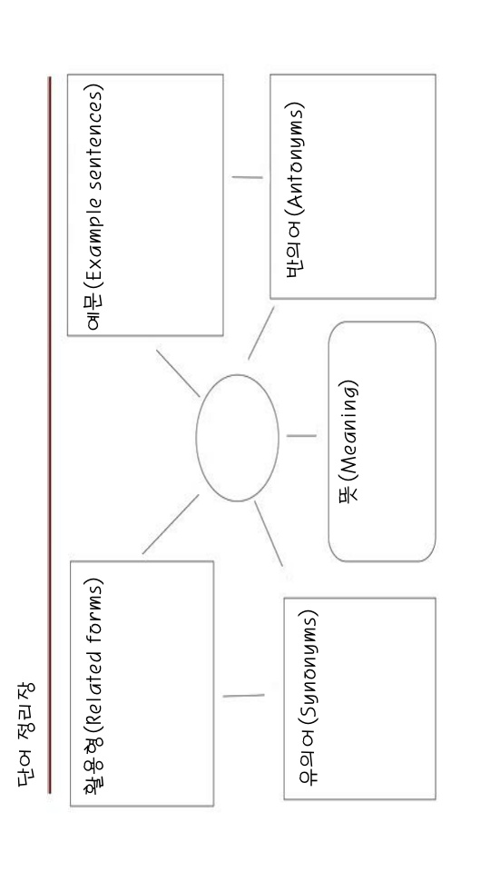
Appendix B: Template of 1st WAT to 3rd WAT 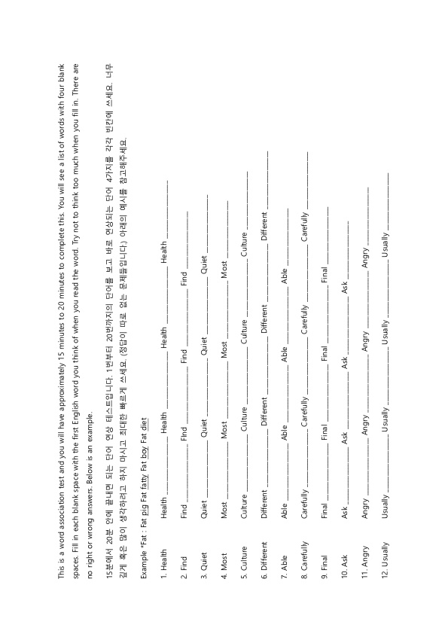
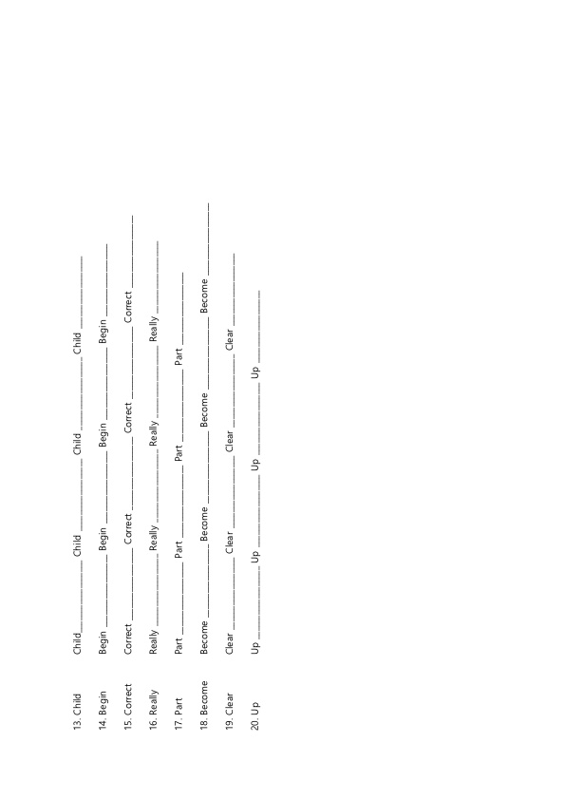
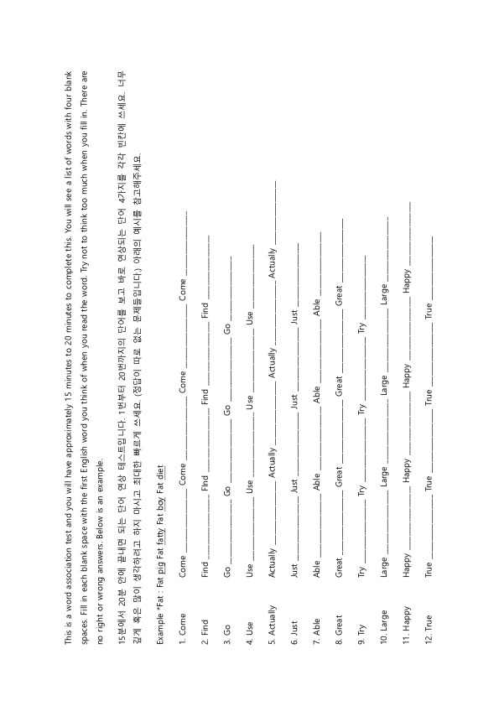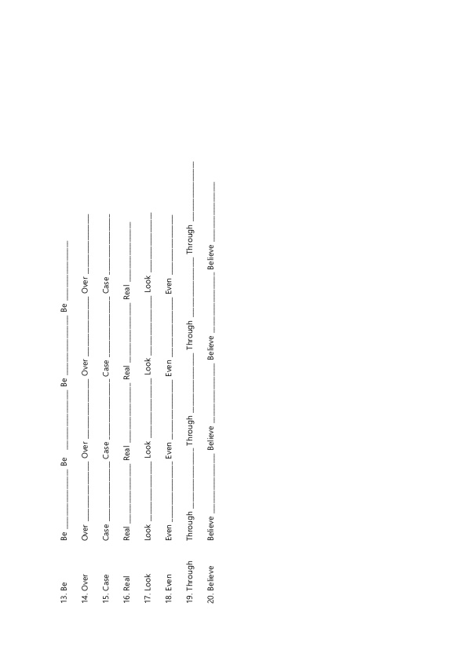
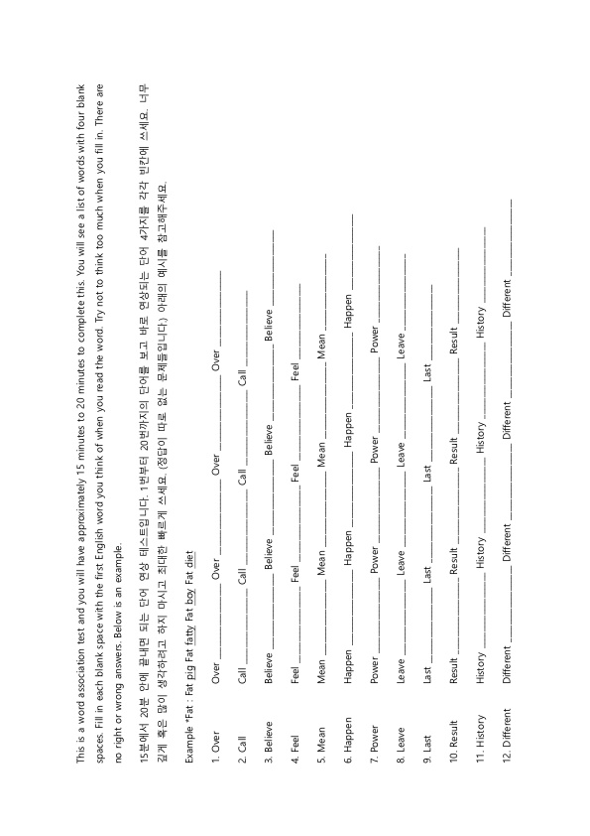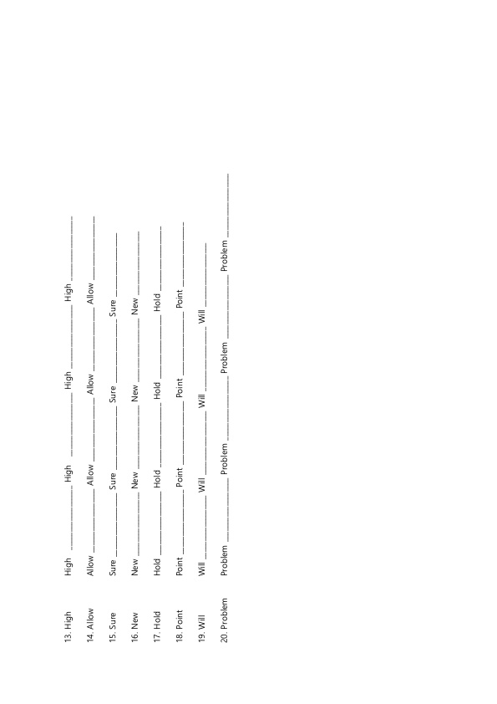
Appendix C: Template of 1st VKS to 3rd VKS
